Name: ___________________________________ | Phone: _________________________
Street Address: ____________________________ | City/State/Zip:___________________
Date of Birth: _____________________________ | Email: _________________________
Occupation: ______________________________ | Daily Physical Duties: _____________
Exercise? What Type? How Often?

Have you had a massage or bodywork before? |  | Last time? How often?
Have you had any issues with the following?

Musculoskeletal / Bulging Discs | Asthma | Varicose Veins
Epilepsy | Skin trouble | Heart disease
Skin trouble | Arteriosclerosis | Arthritis
High blood pressure | Dizziness | Hemophilia
Stomach ulcers | Phlebitis | Contact lenses
Low blood pressure | Depression | Cancer
Pins/pacemaker | Pregnancy | Headache
Bruising tendency | Hernia | Diabetes

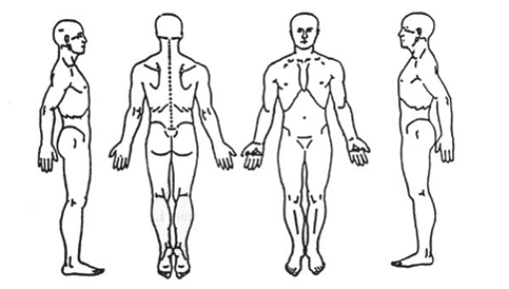

Massage Disclaimer

I understand that the therapeutic massage I receive here is for the basic purpose of stress reduction, relief of muscular tension, spasm, and/or pain. If I experience any pain or discomfort during a session, I will immediately inform the therapist so that the pressure and/or strokes may be adjusted to my level of comfort. I further understand that the massage therapist does not diagnose illness, disease, or any other physical or mental disorder, nor does she prescribe medical treatment, pharmaceuticals, or perform spinal manipulation. I understand that I should see a physician, chiropractor or other qualified medical specialist for any known physical or mental ailments. I affirm that I have stated all my known medical conditions and answered all questions honestly. I agree to keep the therapist updated as to any changes in my medical profile. I also understand that the massage therapy sessions are my personal financial responsibility, and that I agree to pay for these services at the time of treatment unless other arrangements have been made.

Client Signature _________________________________________
Date _____________________________

